Pseudocode:
operations <- string
while operations ≠ exit do
numbers <- list of two numbers
if operations = addition do
print numbers[0] + numbers[1]
else if operations = subtraction do
print numbers[0] - numbers[1]
else if operations = multiplication do
print numbers[0] * numbers[1]
else if operations = division do
if numbers[1] = 0 do
print cannot divide by 0
else do
print numbers[0] / numbers[1]
else
print operation is not acceptable
operations <- string
end if
operations <- string
end while
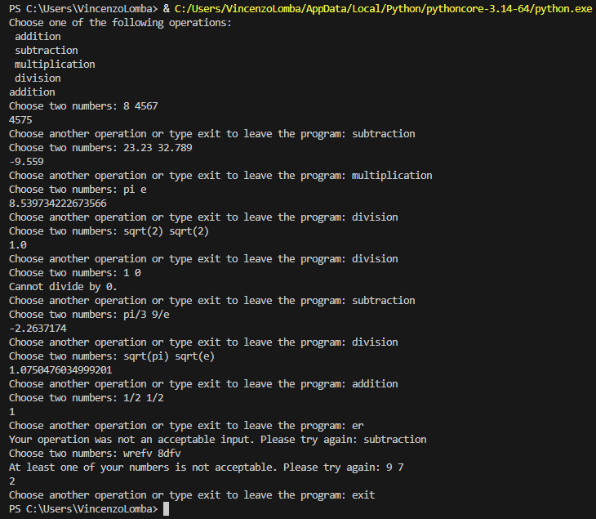
We consider the four main arithmetic operations: addition, subtraction, multiplication, and division. In the flowchart, we consider a string input that the user must provide. We only have four acceptable inputs, other than exit, so we have four options after the input, one for each arithmetic operation. Next, the user must input two numbers, which can be any number. Next, the script should run the appropriate operation according to the input, and then return that number to the terminal. Once the number has been returned, the script will go back to the start, asking for a new input, and the user may continue running the script with the same or different inputs. If the user ever inputs ‘exit’ to that prompt, then the script stops running.
Next, we consider the pseudocode. The input operation can simply be a string that the script will read, while the numbers may be either a list or two numerical inputs. In the pseudocode written above, we’ll take it as a list of two numbers. We run a while loop on operations not being ‘exit’ to do that operation on the numbers provided. The string must be ‘addition,’ ‘subtraction,’ ‘multiplication,’ or ‘division.’ Any other string must not be accepted, since they do not correspond to any of the four arithmetic operations (although we could expand to other operations, given the appropriate mathematical inputs). If the user provides an unacceptable input, the if loop will check for this, return that the string was not acceptable, and ask for a new string input to operations. Lastly, if the user inputs ‘exit’ to operation, the while loop will exit and the script will stop running.
For the actual code itself, we start off with just the menu. We print the menu, showing the operations, then make a string variable ‘operations’ that takes in a string. Next, we have the while loop that runs as long as operations is not ‘exit.’ The basic structure of the code should follow exactly like the pseudocode, which is how I initially wrote it. The nested if loop checks operations to be one of the four strings, and the else branch runs only if operations is none of those strings. Once done, the script asks for a new input to operations, and the loop starts again. Otherwise, the user may type exit to end the script.
Of the four operations, only division has an extra step. The other three arithmetic operations have no limits on what their inputs can be, so long as they are numbers. Division, however, cannot function when the divisor is zero. Therefore, we add an extra if statement to this branch to check whether the second numerical input is zero. If so, then we print that the user cannot divide by zero. Otherwise, the first number will be divided by the second, and the loop moves onto the next step.
The first issue that arose for me was simply the order of statements. In the initial test run, all the regular tests ran as expected. Addition adds, subtraction subtracts, dividing by zero gives the error message, and so on. What looked wonky, however, is when I tested a random string to obtain the error of an unacceptable input. The code reads the operation, but because the while loop starts with the numerical input, the code does not immediately return the error message after an unacceptable input. It asks for numbers first, then returns the error. So instead, the while loop begins by checking that operations is an acceptable input. The if branch runs if operations is not an acceptable input, then asks for a new input. The else branch runs otherwise. This is more efficient and readable than the other way. We could check if operations is an appropriate input, and the else branch running only if not, but each elif branch would need a numerical input statement, making the code more dense than necessary. Therefore, we check if operations is not acceptable, then let the else branch have one numerical input statement and all the acceptable operations.
The next issue that comes to mind is the numerical inputs. In that first test run, I only used integers, but clearly arithmetic can be done to floats too. The input needs to be written as
numbers = [float(val) for val in input("Choose two numbers: ").split()]

instead of
numbers = [int(val) for val in input("Choose two numbers: ").split()]

‘numbers’ is in fact a list, not a float itself, following the way we did in pseudocode. The input is split up into two numbers, and without any input into the split function, it assumes ‘ ’ as the separator. input.split() returns a list, which we take values from and turn those into floats. Then we make a list of the floats, so we have two float values. Before, if inputting a decimal, int would round the input, giving us the wrong answer. The script would not return an error, so this would not be noticeable immediately unless testing with decimals.
Another acceptable input to consider is fractions, which can be typed as ‘1/2' or ‘1/3' and so on. These are strings that need to be separated appropriately and then evaluated into floats for the actual operation to be run. For simplicity, I assumed that any fractions input will be between integers, no decimals, since fractions are defined as an integer divided by another. In order to do this, we need to check whether an input or both inputs are fractions based on whether the separator character ‘/’ exists in the string. After obtaining the numerical inputs as a list of strings, we run an if statement to check if ‘/’ exists in either string, then converting appropriately into a float. For example, if a user inputs ‘1/2' into the terminal, the if statement converts it into 0.5, which is then used for whatever operation is intended. If there is no ‘/’ character, then the string is directly converted into a float.
The last issue that appears is irrational numbers, such as ℼ and e. In user input, these are not just strings, but can only be strings. They cannot be converted into floats because they cannot be fully written as numbers, otherwise they would not be irrational. To do this, we consider whether or not the string can be converted into a float at all. This differs from the fraction case, because the if statement already handles this situation, so any other string will fall under the else branch. I did this by a try and except block, where I made the value a float. The except branch runs if we get a ValueError, since this pops up in the terminal when a string cannot be converted into a float.
There are three main irrational numbers or types we may consider for this scenario: ℼ, e, and square roots. If a user inputs ‘pi’ or ‘e’ into the terminal, then we need to convert the string into that value. For this, I imported the math module such that ‘pi’ gets converted to math.pi and ‘e’ to math.e, both of which are floats in Python. For square root values, the user input will be ‘sqrt(x)’ for some integer or float x, and we check that ‘sqrt(’ is in the string. This also means we cannot accept, for example, ‘sqrt4’ from input. Because we need to obtain a substring, and then convert that substring into a float, the location matters, and it differs between ‘sqrt’ and ‘sqrt(’ being typed. With this substring, I converted it to a float, then changed the value in the list to the square root of the float using math.sqrt.
All other string inputs that are not ‘pi,’ ‘e,’ or ‘sqrt’ should not be accepted, so the else branch will ask the user for new input. To simplify the code, instead of checking for fractions first, I instead tried converting the string to a float first, then ran the except ValueError branch. In this branch, we first check for ‘/’ to convert the fraction into the appropriate float, then the square root case, ℼ, and e. If the string does not match any of these cases, then we prompt the user for new numerical inputs. The last possible edge cases are, for example, a user inputs ‘2/pi’ or ‘sqrt(e)’ as their numbers of choice. Just like when we check in the general case, we must see whether the numerator or denominator or both are ℼ or e. Otherwise, the substring will be directly converted to a float.
After running a few tests, the last issue I came across was the rounding error that comes with using floats in Python. For example, inputting numbers with one digit after the decimal point or three or more digits after the decimal point, did not cause this issue when adding or subtracting. However, using two digits after the decimal point caused an issue for me when adding or subtracting, but not for multiplying or dividing. The printed result contained repeated ‘9’s or ‘0’s followed by some other digit, when in fact, that is not the correct result. To fix this issue, I changed the printed value in the addition and subtraction cases to only contain 8 significant digits, so these branches printed f-strings instead of only running the operation. This also ensured that in cases where I have an irrational input, like shown in one of the unit tests above, there is still some precision shown to the user.
In terms of performance, the script runs pretty quickly, as most of the statements are if statements. There are only two for loops, both of which only run twice, and one of the loops may not run at all, depending on the numerical inputs. The while loops run while certain conditions are true. The first continues as long as the user does not input exit to the appropriate prompt, while the second continues while the list of numerical inputs has not been fully converted to floats. To improve the script’s runtime, the only way I can personally think of is limiting the possible numerical inputs the script can accept. This would mean removing cases like ‘pi’ or ‘e’ or square roots from being accepted and only allowing purely numerical inputs. For example, having inputs such as 23.78 and 34.7854 are possible, but sqrt(e) would not be.

